**INFORMATION:**

You will be participating in front line firefighting activities and/or medical calls and will most likely be exposed to the hazards normally associated with those responsibilities. Responding on 911 calls to deal with the various emergencies that may occur in the community will prove to be both physically and mentally taxing. Individuals are encouraged to consider this before applying. Some Departments offer support membership that does not include any firefighting responsibilities.

**Why become a Volunteer Firefighter?**

There is no personal financial gain. However, the more that you commit yourself to this community service, the more you will be rewarded.

Through training, you can gain skills such as: fire prevention, firefighting skills, child and adult C.P.R., defibrillator use, first aid, advanced life saving techniques, hazardous materials recognition and response, and safe emergency driving.

The skills that you learn will not only benefit Highlands County, but will give you the ability and confidence to assist your own family and friends in times of emergency.

Most importantly, you will receive the deepest, most heartfelt “THANK YOU” possible from the victims and families of those whose lives and property you have saved while serving as a volunteer firefighter.

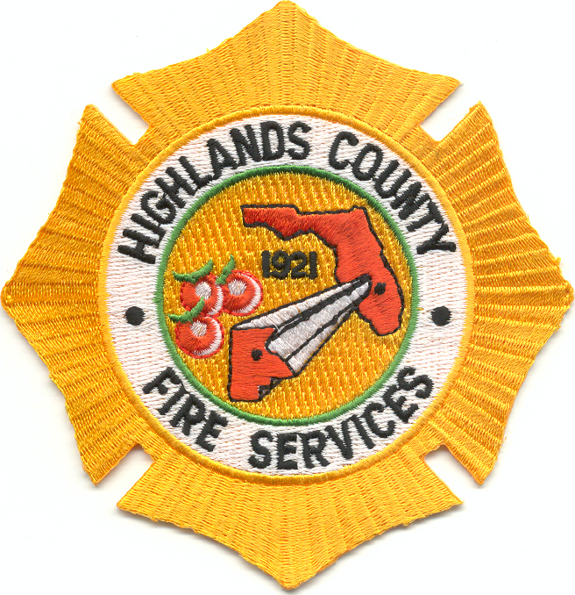

**35 40 45 50 55**

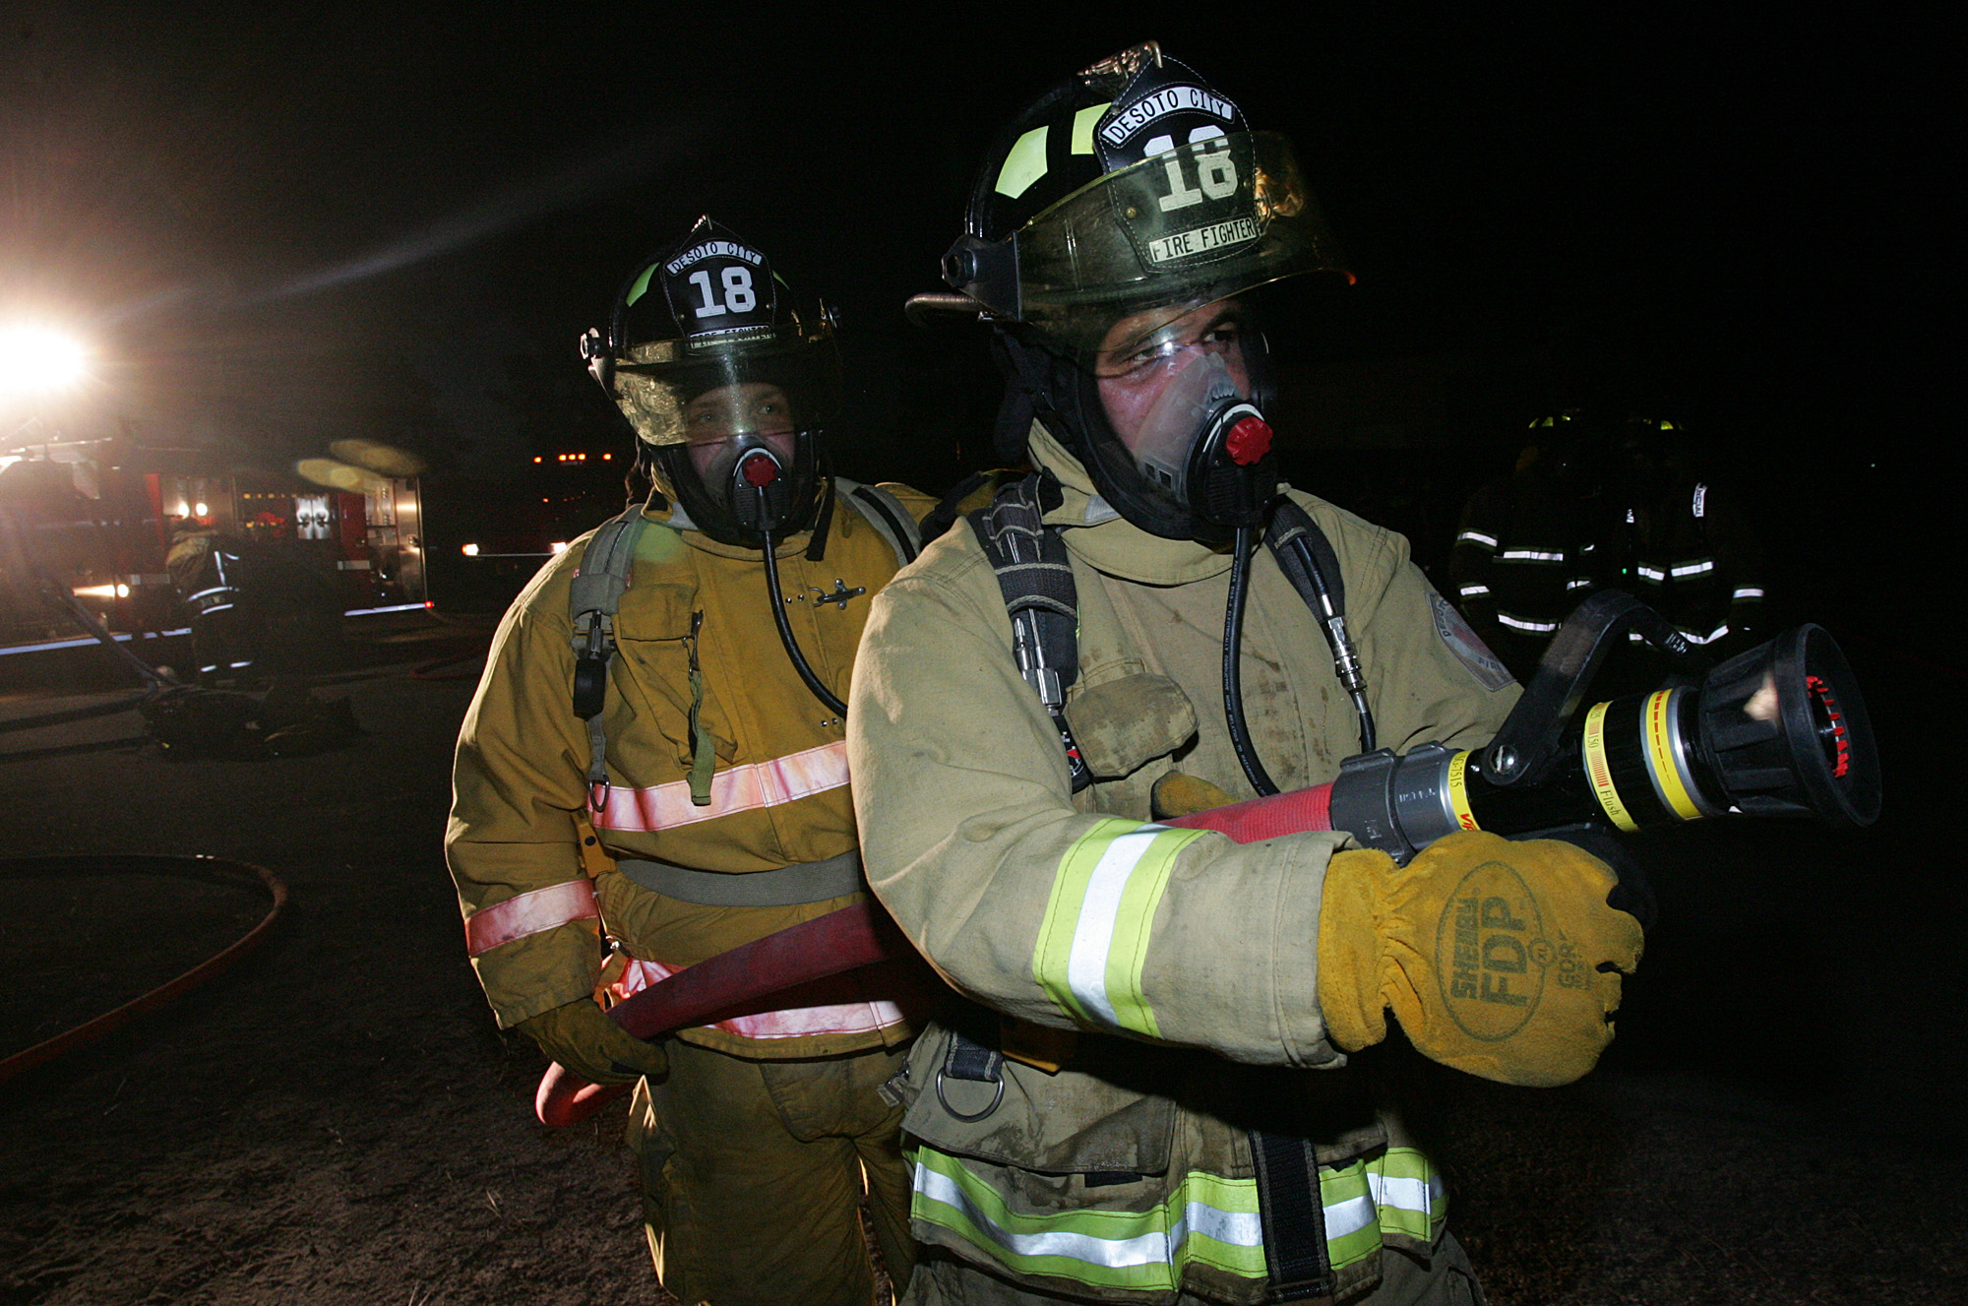

**SO YOU WANT TO BECOME A FIREFIGHTER**

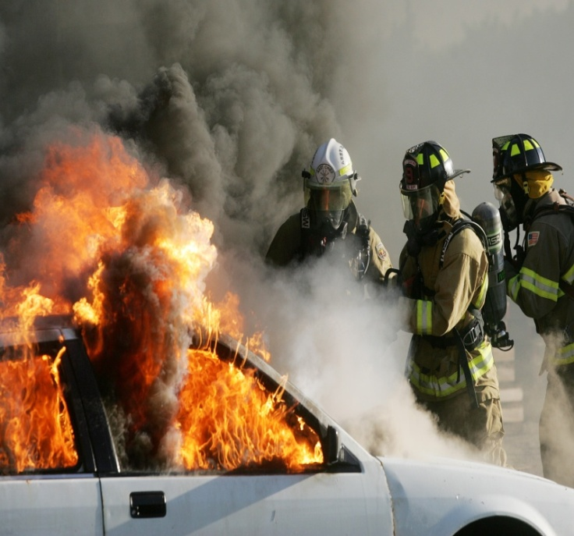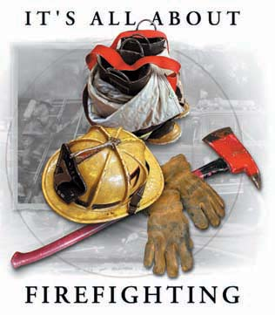

**Highlands County Fire Services**

6850 W. George Blvd. Sebring Fl. 33875

Ph: 863-385-1112

Fax: 863-402-7404

**COUNTY FIRE DEPARTMENTS**

**DeSoto City Fire Department**

6800 West George Boulevard

Sebring, 33875 Phone – 863.385.6870

------------------------------------------------------

**Highlands Lakes Fire Department**

2840 North Highlands Avenue

Avon Park 33825 Phone - 863.452.3807

------------------------------------------------------

**Highlands Park Fire Department**

1317 Columbus Street

Lake Placid 33852 Phone - 863.699.3711

------------------------------------------------------

**Lake Placid Fire Department**

12 West Interlake Boulevard

Lake Placid 33852 Phone - 863.699.3753

------------------------------------------------------

**Leisure Lakes Fire Department**

2874 Lake June Boulevard

Lake Placid 33852 Phone - 863.699.3712

------------------------------------------------------

**Lorida Fire Department**

1172 U.S. 98.

Lorida 33857 Phone - 863.655.0122

------------------------------------------------------

**Placid Lakes Fire Department**

300 Washington Boulevard North West

Lake Placid 33852 Phone - 863.465.7805

------------------------------------------------------

**Sun’n Lake Fire Department**

460 Sun’n Lake Boulevard

Lake Placid 33852 Phone - 863.699.3708

------------------------------------------------------

------------------------------------------------------

**Venus Fire Department**

45 Venus Clubhouse Road

Venus 33960 Phone - 863.699.3720

------------------------------------------------------

**West Sebring Fire Department**

2300 Longview Court

Sebring 33870 Phone - 863.471.5344

**Volunteer Firefighter Benefits**

Volunteering as a firefighter does not come without its benefits. First and foremost is the knowledge of making a difference in the lives of people who live and play in the community. They protect and rescue people, save their property, and in some cases their lives. Volunteering as a firefighter includes the following benefits:

* All required training is provided and paid for by the department.
* All required safety equipment and gear is provided and paid for by the department.
* Volunteering can provide the necessary experience and background for individuals seeking career employment in the fire service.
* Successful candidates will receive a comprehensive medical evaluation paid for by the department.
* Worker’s Compensation, Accident and Disability insurance provided.

**VOLUNTEERS HAVE THE OPPORTUNITY TO:**

* Learn teamwork, responsibility and

gain a sense of achievement and accomplishment.

* Explore the possibilities of a career in firefighting or emergency medicine.
* Provide a skilled service to their community.
* Participate in the departments social events.

**THE APPLICATION PROCESS**

* Must be at least 18 years of age,
* Complete and return a Department Membership Application.
* Verification of a good driving record
* A favorable background history
* Complete a thorough medical evaluation.
* Attend Department meeting
* Complete probationary period
* Respond to calls with limited capacity depending on training.
* Complete Firefighter One Course.

